Channel Notching in NetSim
Note: Channel notching code will work only for a single Channel, single CR-CPE and for at-most one Incumbent.

Steps:
- Open the NetSim.sln folder inside the extracted Channel Notching folder.
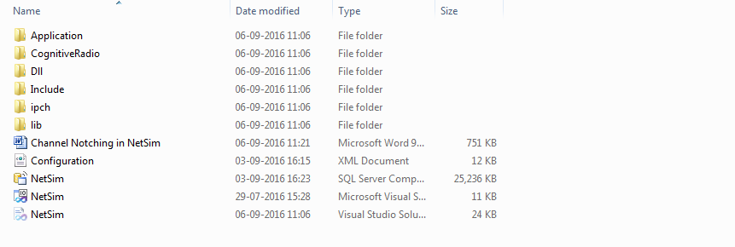
- In the Solution Explorer, go to Cognitive Radio à 802_22.h and open it.
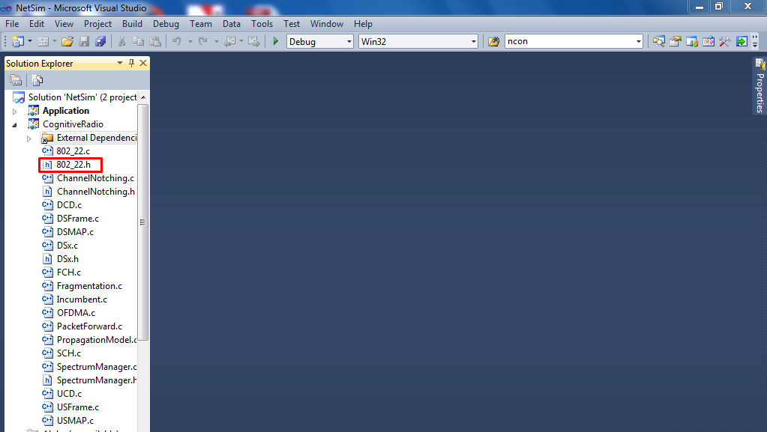

- If you want to enable Channel Notching, uncomment (if commented)
#define _CHANNEL_NOTCHING_
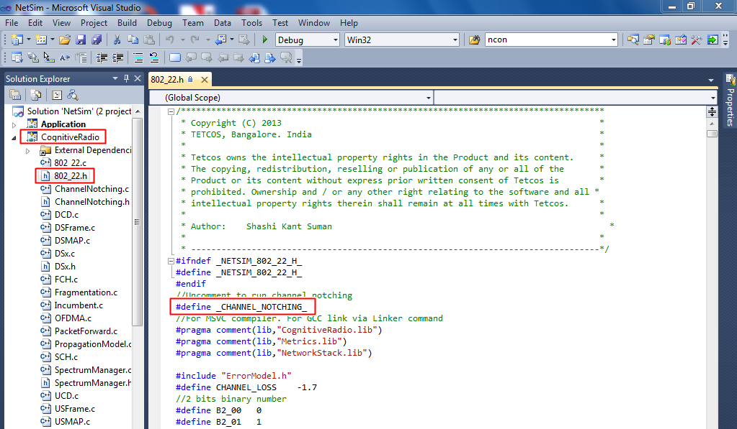

- Right click on Cognitive Radio à Build

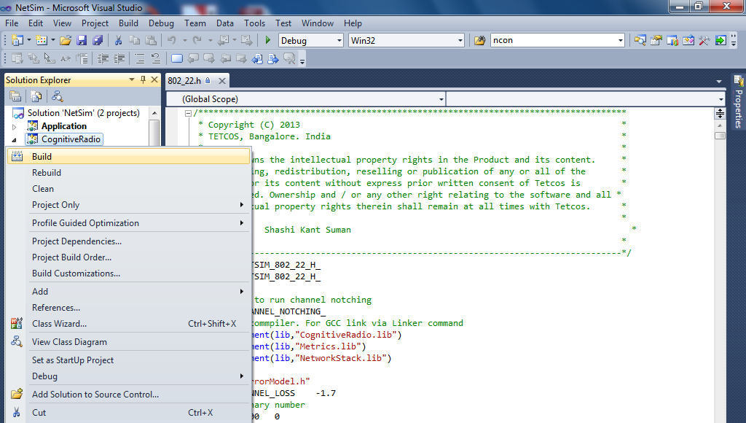

- You should see a message in the Output window as shown in the following figure.
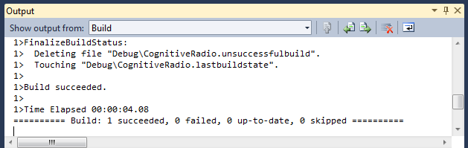

- Inside the extracted Channel Notching folder, go to Simulation folder à DLL folder and copy the file libCognitiveRadio.dll
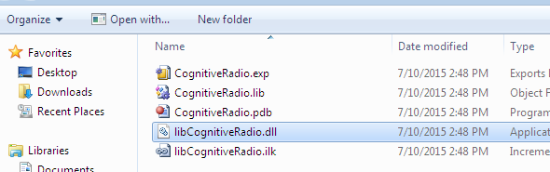

- Go to the installed directory where NetSim is installed and open bin folder.( It will be something like “C:\Program Files(x86)\NetSim Standard\bin”)
- Rename libCognitiveRadio.dll file which is already present there. (to something like libCognitiveRadio_default.dll for backup purpose. In case if something goes wrong, you can again rename this file to libCognitiveRadio.dll)
- Paste the new libCognitiveRadio.dll file that you copied from the DLL folder.
- Now executing Cognitive Radio in NetSim will including channel notching.
- A sample Configuration.xml file is provided inside the zip folder.
- Or create a scenario as followed
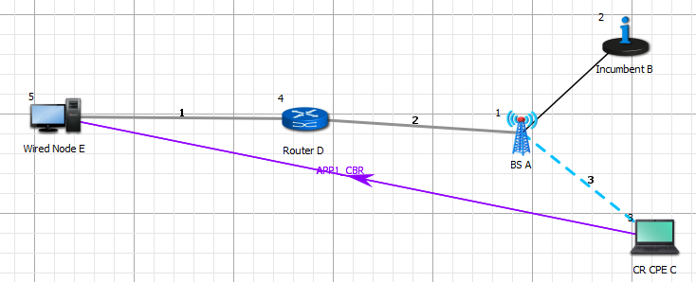
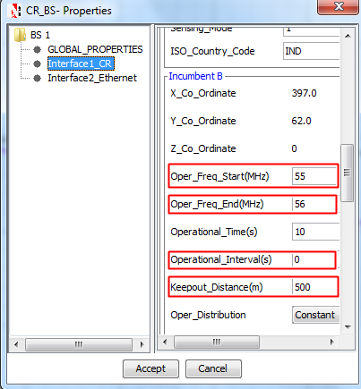
- And set BS properties as

- Open that scenario in NetSim and run it for both the cases: with channel notching and without it.
  - To run without Channel Notching- rename the present libCognitiveRadio.dll (to something like libCognitiveRadio_notching.dll) and rename original dll to libCognitiveRadio.dll (earlier renamed to libCognitiveRadio_default.dll).
- The throughputs obtained will be 0.009578 and 0.000000 respectively.

Explanation
Channel Notching basically allows the CR-CPE to use the free subchannels which are not occupied by the incumbent, as compared to the standard case (without channel notching), where the entire channel is blocked even if some of the subchannels of that channel are being used by the Incumbent.
Hence enabling Channel Notching will give more throughput.

